

Gavin Whitehall (S0909256)

BSc (Hons) Computer Games (Software Development)

Mobile and Ubiquitous Computing Coursework

(MHG420877)

Module Leader: Robert Law

*I confirm that the code contained in this file (other than that provided or authorised) is all my own work and has not been submitted elsewhere in fulfilment of this or any other award.*

**Signed: Date: 19/12/2013**

Table of Contents

1.0. Code Breakdown and Explanation 3

1.1. Main Activity 3

2.0. Storyboards 4

3.0. References 5

3.1. Development Resources 5

3.2. Asset Resources 5

# Code Breakdown and Explanation

## Main Activity

The Main Activity is the only activity and Java class in the project, and is supported by two libraries (Google Play Services and Android ActionBar) and 3 XML files (activity_main, searchable and android_main_actions).

As mentioned all the Java code to generate this project is located within Main Activity and its functions. The first function called is the OnCreate() function which has been optimised to call the functions SetUpMap() and AddMarkers() keeping it tidier and readable. The OnCreate() is also designed create a Geocoder which is used for parsing strings into location events and set up a listener for click to the marker info window, which will be discussed later.

The function to be called from OnCreate() is the SetUpMap() function which is designed to create the map from the libraries and set the default camera location to Glasgow’s positon. It also enables the functions relating to GPS location, map rotation and compass.

AddMarkers()takes two list items cityList[] and venuelist[]and fills them with the result of 11 and 13 SetMarker()return values, respectively. Then for all the items in each list it will create markers on the map.

MarkerOptions() is responsible for creating and returning a MarkerOption variable from the parameters inputted on call.

EventClicked()takes the inputted marker parameter and then checks it against all the list items in each marker list. It then calls the ToWebsite() function with the associated string in order to parse and open the web browser to the correct webpage.

The Action Bar items are handled onOptionItemSelected() with a case and switch statement for all of the Action Bar items ID. From here the input for all the city changes, the search, map changer, and GPS location distance are handled.

The MoveTo()is called by the search function that requires the camera to move to a new location and takes the string from the search to do so. It first checks for any active string markers and removes them, then attempts to create an address (with the Geocoder) from the inputted string. Upon creation of the address it adds a map marker and animates the camera to the new marker. If no address can be parsed from the location input, a toast will be created to give this feedback to the user.

Finally GetDistance() is used to calculate the distance between the inputted latitude and longitude, and Glasgow city centre. It will create a PolyLine between this positon and Glasgow and calculate the distance with the distanceBetween() function.

# Storyboards

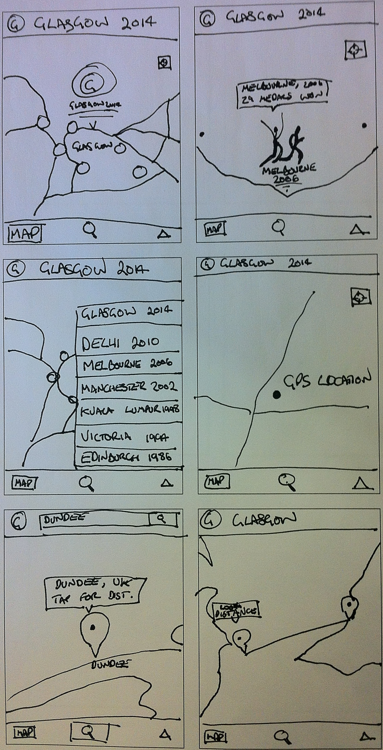

# References

## Development Resources

https://developers.google.com/

http://www.vogella.com/articles/Android/article.html

http://developer.android.com/training/index.html

http://stackoverflow.com/

http://www.androidhive.info/

http://blog.zeezonline.com/2013/11/install-google-play-on-genymotion-2-0/

http://www.genymotion.com/

## Asset Resources

http://www.glasgow2014.com/

http://en.wikipedia.org/wiki/Commonwealth_Games

http://www.thecgf.com/

http://developer.android.com/design/style/iconography.html

http://www.creativereview.co.uk/cr-blog/2011/august/glasgow-2014-commonwealth-games-pictograms